Jira –

Intellij-Cucumber, Selenium, Java, junit, Maven, git-

Jenkins-execution engine

Feature- login

Login registered user-Scenario1-

Examples:

Usernamepwd

Login guest user-Scenario2

Given agregar una tarjeta credito

When

Then

Retail,

Arcserv

8125561139 – sadhu sevaka

Basilwoods – 9010434434- bhagyavathi

Modify the host file

Feature file not recognized in Intellij

CheckSettings->Editor->File Types. VerifythatCucumberScenariois set to a RegisteredPattern of *.feature.

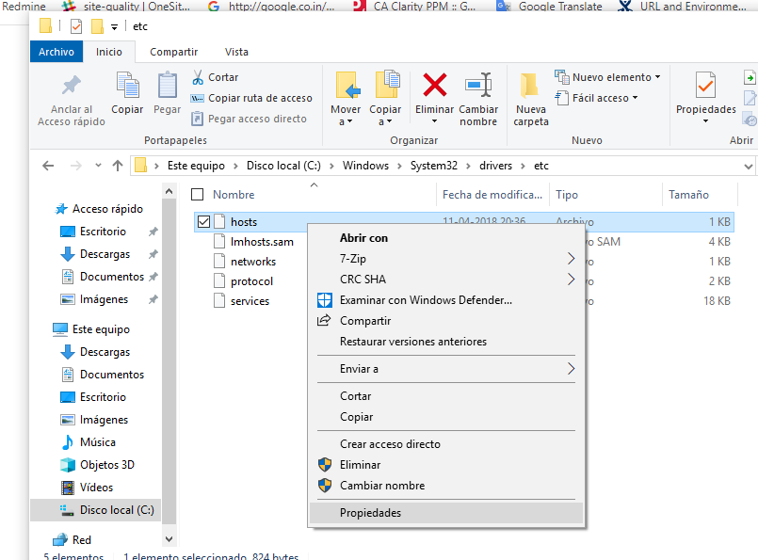

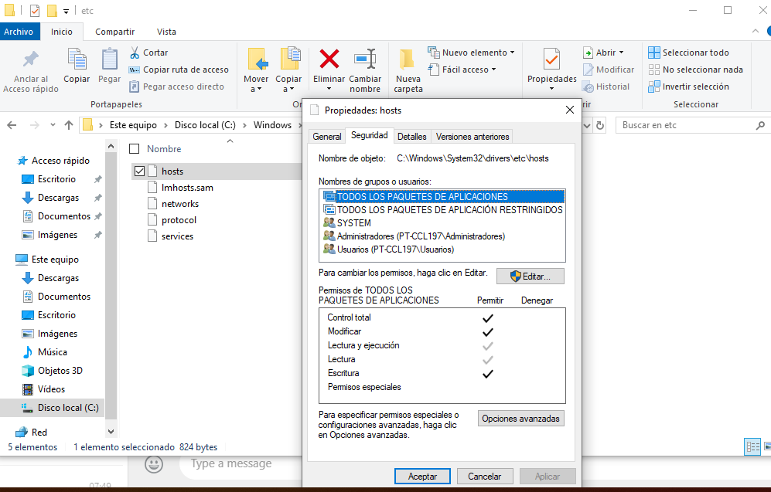

**Bamboo**

Thecost of Bamboochangesdependingonthenumber of buildagentsrequired, unlikemostotherAtlassianproductswhich are normallychargedbasedonthenumber of users. A buildagentiswhatyoudownload to the server to carryouttheinstructionsoutlined in your plan. The more plansyouhave; the more agentsyouwillprobablyneed, otherwiseyouriskcreating a backlog and slowingdowntheprocess.

Most of itsfunctionalityhowever, is pre-built. In otherwords, itdoesn’trequireplug-ins. Italso has built-in deploymentproducts and isseamlesslyintegratedwithotherAtlassianproductslikeBitbucket and JIRA. In fact, withBamboo a lot of tasks are available as built-in options. It comes withanextensivemenu of toolsthatyou can use to buildyourapplication. Jenkins, in comparison, requiresthatyou set everything up – it’sallthere, justnotbuilt-in.  
Ifbudgetisnot a factor, and youalready use Atlassianproducts, thenBambooisforyou. Itgivesyoutheconvenience of havingeverything in place, set-up and ready to goalmostimmediately.

Whenit comes to theuser-interface, Bamboo’sistidier and more intuitive. Each time a new taskisadded, itprovides more help and guidancethroughtheplan’sbuild and deploymentstages. Jenkins ispurelybasedonfunctionality. Bamboo vs Jenkins islikecomparing Word and WordPad. Word isfar more user-friendlybutWordPadis a basic, free alternative, butbothoffergoodfunctionality.

**Jenkins**

ThebigdifferencebetweenBamboo vs Jenkins isthat Jenkins is Open Source – it’s free.

Integrationwith JIRA and Bitbucketislimited. Theprocessrequiresadditionalcomponents in theconfigurationwhichtakes time and labour. WithBamboo, basicconfigurationoptions are alreadybuilt-in. There are severalplug-insthatenable Jenkins to integratewith JIRA, each in a differentway. To findoutwhichisthebestforyou and yourneedswilltake a bit of trial and error – whichlengthenstheprocessevenfurther.

Additionalworkisrequired to maketheuser-interface more intuitive. Thebenefit of thisisthatitleaves more roomforcustomisation and creation, and allowsyou to choosefrom a range of differentplug-in options. There are only 100 Bambooplug-ins in theAtlassianenvironmentcompared to Jenkins which has over 1000. Of course, it’simportant to rememberthat a lot of theseplug-ins come as standard withBamboo.

Jenkins isverymuchabout simple functionality. It’s a general CI toolthatoffersbasicautomation. It’sthemostcommon CI toolonthemarketwith a largecommunity of users. Bambooisfar more specific and focusesonbuild, test and deployment.

**Summing up**

At theend of theday, yourchoicebetweentheseequallyefficientautomatedtools comes down to thefollowingfactors:

* Budget
* Preferencesforuser interface
* Convenience of configuration and set-up (NB. ExistingAtlassianproducts in use)
* Access to plug-ins
* Desire to buildcustomplug-ins

<https://www.airbnb.cl/rooms/11802327?location=Santiago%20de%20Chile&adults=1&guests=1&toddlers=0&check_in=2019-03-01&check_out=2019-04-30>

<https://www.airbnb.cl/rooms/32491431?location=Santiago%20de%20Chile&check_in=2019-03-02&check_out=2019-05-01&guests=1&adults=1&s=XexGEKZ2>

niceviewwithwifi, Near Baquedano line 1 for 1 guest- 340805 fortwomonths

<http://portalcomercial.qa.labchile.cl:8888/login/logout/platcom>

**IsGitdifferentfromGitHub?**

**A.** [**Git**](https://en.wikipedia.org/wiki/Git)is a revision control system, a tool to manage your source code history. [**GitHub**](https://en.wikipedia.org/wiki/GitHub) is a hosting service for Git repositories. So they are not the same thing: Git is the tool, GitHub is the service for projects that use Git.

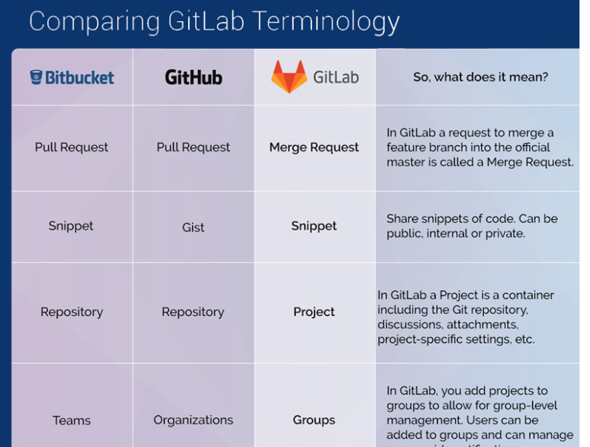

Bamboo vs Jenkins

Jenkins isfree ,usedfor CI,CD

Bambooisbyatlassian ,east to integratewith jira, more userfriendlywithbuilt in features.

Jenkins, bit bucket, katalondocumentationalongwithEdward

4 nivels,

4 productos

Importar conexiones in SQL Developer

Clave de encryption es 123

VENTA EN CAJA

Login as executivo

Click venta en caja

Enter RUT- rut de persona o rut de empresa

9.380.347-7(persona)

79869590-8(empresa)

Rut de empresa no mostrar ofertas

3 PRODUCTOS OFRECEMOS

SEGURO- Tiene 3 seguros- auto, salud, viaje

AVANCE-

CONSUME-

INTERACT IS PROVIDING THE DATA

VER MAS-

Derivar executivo, for 3 type de productos necessito verificar exitosa y no exitosa

agenda posterior for 3 type of productos- necessito verificar exitosa

sin oferta es cortito

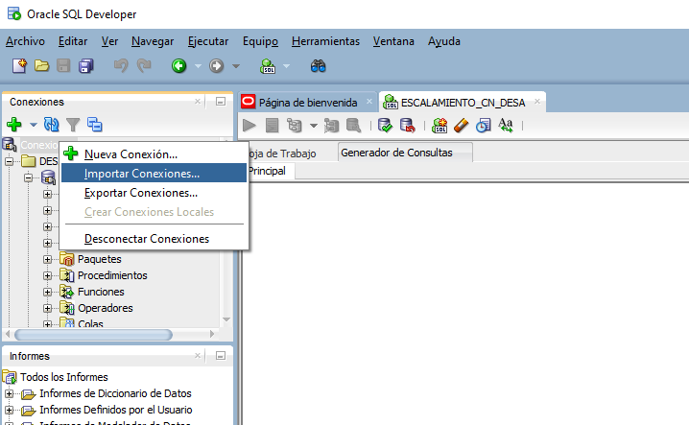

Help marco

Meeting at 260

Katalon

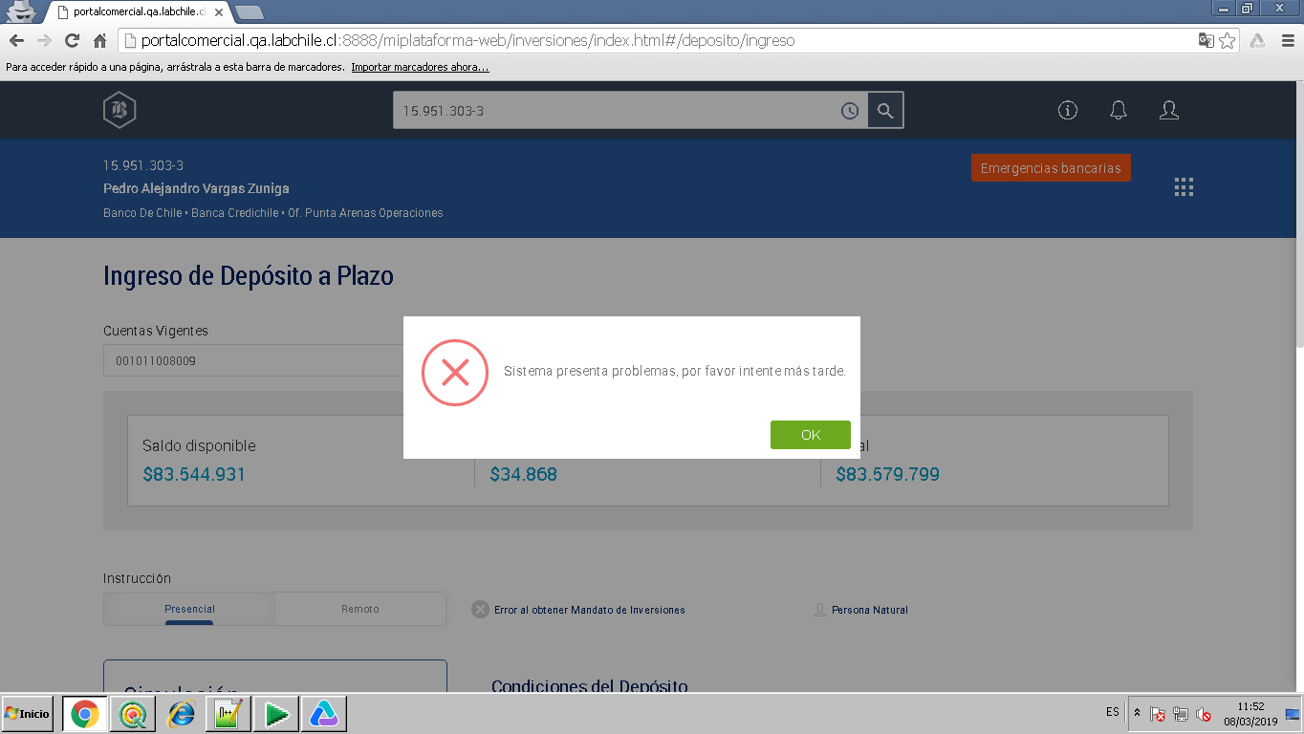

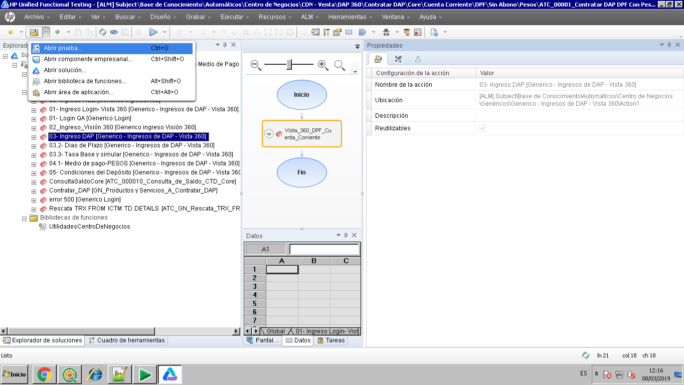

Control de limites test path in ALM

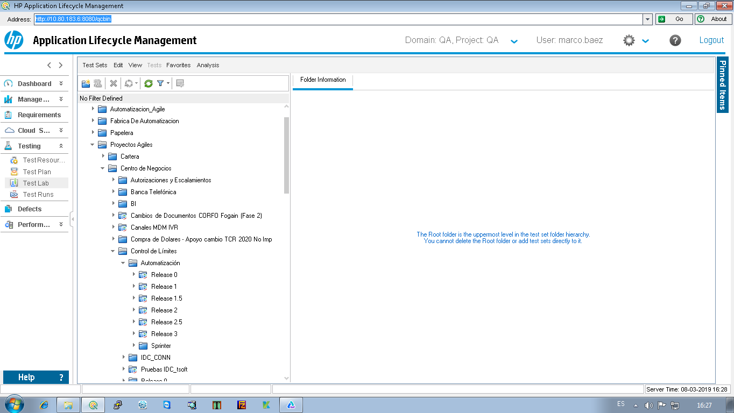

ATC_0001_CDNPCCON_362_Agregar_Sin_Validar_Tipo_Garantía_HIP_Bienes inmuebles_Casa

Step in

Stepout

Stepover

To watchthe variable value, clickon variable, rightclick and add to watch

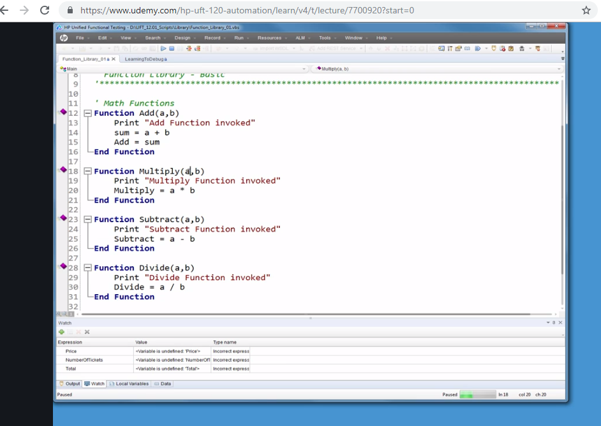

Le puse salía emporal

Pusiste

Habilitarlo

Remote machines

152.139.28.65

PRUEBAS DE CAJA

|  |  |
| --- | --- |
|  | Prioridad |
| 1 | Casos de consulta |
| 2 | Depositos |
| 3 | Pago |

To open caja

Internet explorer

Caja QA

Open system

Labchiles\stsdom

Control panes – java 1.6 FOR CAJA

Pruebas de caja tiene una precondición de login

Sistema de caja login

Click internet explorer and click caja

Jhenriquez

Banco02

Cuenta de Ahorro 5006206107

Cuenta de Ahorro- 80000801107

RUT 10394873-8

Record and run settings to be checkedforconfiguration

http://192.168.158.22:84

user: asarostegtpass: Banco1313

2040- conexión de database error

2050- same

We can Copy as actionor use as Externalaction in a UFT test

Adminlogin

‘mcampero

‘banco03

38705-cuenta corriente

Cuenta-001979575619

Serie-2978079

UFT Installations

\\152.139.28.77/compartida/Instaladores/UFT

Change Fecha contable

Consulta balance intermedio- anotar monto and enter in fin de dia de caja

Fin de dia de Caja-

Fin de dia sucursal

A veces Cerrar sucursal con sqldeveloper- journalqa-tablas-officina- data tab-id 794- changeit to Cerrada

Si hay error mientras ‘Inicia dia de caja’, entonces Change status of id 794 to ‘Reiniciada’

Inicia de dia de sucursal

Incia de dia de Caja

2750692

1550

2766092

2796092

Reversar avance manualmente.

No puede avance mas de 3 veces in un dia. En este caso necessito Reversar

Operacions de caja- journal-mostrar journal. Selección avance y click Reversar

Ya estalogeadoerror , entonces

LoginConsola admin- Mantencion de usuarios - 794-desconexion forzada

Cmunozpo

‘cajero22

1720- código servicio

Finalizar cliente error--- terminate caja in taskadministrator and open

Contingentes error- Operacions- transacciones contingentes

Existen lotes abiertos error- operaciones- mostrar/cerrar lotes abiertos

4993904

Cisco anyconnect

LABCHILE\STSDOM

Banco01

Waitstatement

Elementidentification

POM

WebElementeLogin = driver.findElement(By.name(“Login”);

EntertextusingsendKeys

Java script executor

Driver.findelement(By.id()).Senkeys

Exceptions

Webdriver

timeout

Nosuchelementexception

Nosuchwindow

Noalertpresent

Scroll mouse

Actions actions = new Actions(driver);

Try catch block can be used to handleexceptions

actions.moveToElement

How to click a link

driver.findelement(By.linktext(“google”)).click()

entertext

dirver.findelement(By.name(“Name”)).SendKeys(“Sivag”)

Launchingthe browser

WebDriver driver = new ChromeDriver();

Checking an elementisdisplayed ,isenabled or isselected in selenium

‘ **boolean**buttonpresence = driver.findelement(By.Classname(“sivag”)).isDisplayed()

Listboxselection

SelectBytext()

SelectByvalue()

SelectByIndex(0)

For(i=0; i<size; i++)

Element.get(i).click

Browser navigations

‘driver.navigate.back()

‘driver.navigate.forward()

Handling pop ups in selenium web driver

Voiddismiss()

Example: alert().dismiss()

Voidaccept()

Example: alert().accept()

VoidSendkeys(string, “ok”)

Exampleassertstatements

ExampleWaitstatements

Thread.sleep

Wait

Seleniumgitpull

63869

470

bcSiva12$

https://expert.adpsoluciones.com/Expert/(X(1)F(Esqu5amsfwZsainSmyJMAplyygxvuNTetGzPoalBrImLhwWa26vobWbtbRbM2o-gQ5U3D2W_1Jrrv9gURdaPmBnkuKS3jaxab5qa725L4AGJB_vwsmS0U167E9h9UTpgoaVRIkNM5nPFSvOCwIeiCwdez7nXHyOGQ3qbDLn7l4OERTVaBMLbCuKh60FLmEfF0))/Sistema/Seguridad/Campswr.aspx#

verifytheflow

assertions

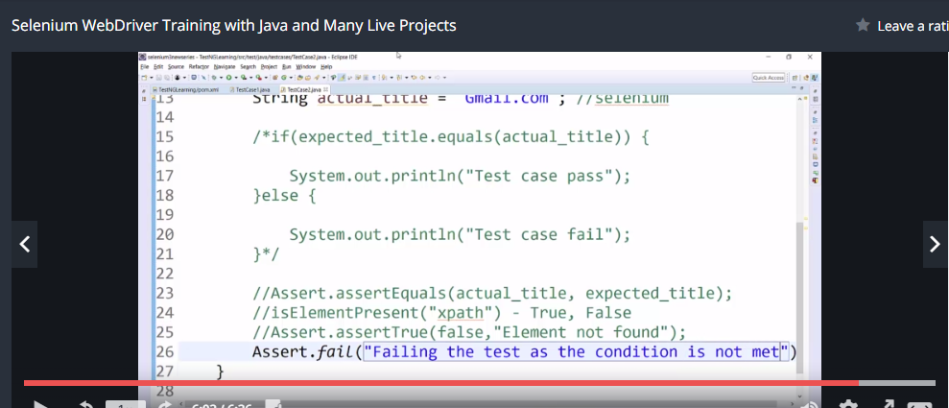

Softassertions

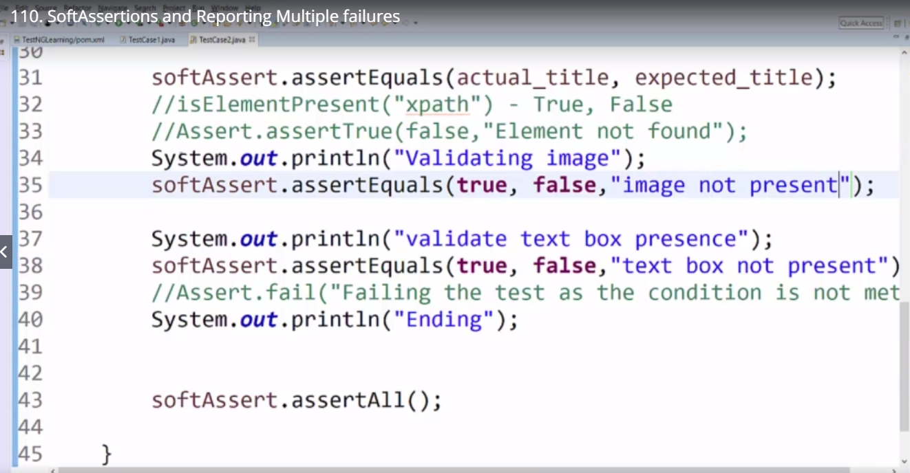

Dependenttests

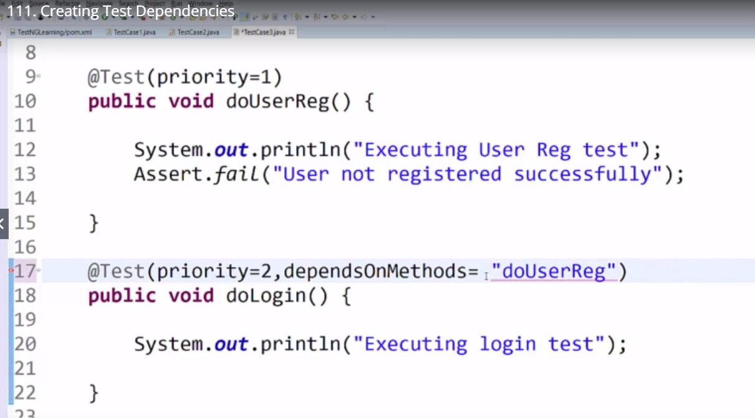

JAVA Basics

Java compilerthatconvertscodeinto byte code

Aftercompiling .java file isconverted to .class file

JDK getsdownloadedalongwith JRE and compiler.

JRE contains JAVA Virtual machine and library files

Java Interpreter

JVM

Créate class

All objects are stored in Java heap- memory space taken by JVM

If there is no reference variable then JVM cleans the objects from java heap….this is called garbage collection

Reference variable is a variable thatstorestheaddress of anobject

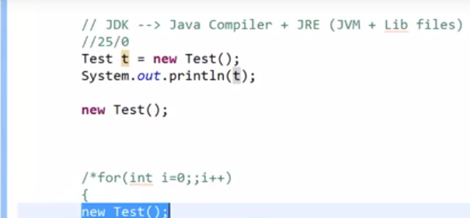

**In java “String” is a class and not a datatype and it can be instantiatedlikeotherclassesString s = new String();**

In Java, instantiation mean **to call the constructor of a class that creates an instance or object of the type of that class**. In other words, creating an object of the class is called instantiation. It occupies the initial memory for the object and returns a reference.

Declaration and initialization of primitivevariables

• Integer➢ inti= 234242425; ➢

long l = 284798247287427427428947l;

//suffix ‘l’ ismustotherwisecompilerwilltreatit as integer.

• Float➢ float= 2342.34f //suffix ‘f’ ismustotherwisecompilerwilltreatit as a double➢ double = 298472847242478927.2942949274

• CharacterCharc = ‘j’; // only single characterisallowed

• BooleanBooleanb = true // only true or false isallowed

• booleanb = true;

String s = ( b == true ? "True" : "False" );

Ortheabove can be written as

• booleanb = true;

String s;

if(b == true){

s = "True";

}

else{

s = "False";

}

Selenium – Databaseconnection

**package**com.BCH.selenium.pruebas;

**import**java.sql.Connection;

**import**java.sql.DriverManager;

**import**java.sql.ResultSet;

**import**java.sql.Statement;

**import**org.junit.Test;

**import**com.BCH.selenium.abs.COnexion;

**publicclass** DBCONEXION2 **extends**COnexion {

@Test

**publicvoid**conexion() {

**try**{

//step1 load the driver class

Class.*forName*("oracle.jdbc.OracleDriver");

//step2 createtheconnectionobject

Connectioncon=DriverManager.*getConnection*(

"jdbc:oracle:thin:@200.14.169.238:1521/ORION","VISTA_360_CN","VISTA_360_CN_ORION2K16");

//step3 createthestatementobject

Statementstmt=con.createStatement();

//step4 executequery

ResultSetrs=stmt.executeQuery("select * from FST_NAME,LAST_NAME,MID_NAME from S_CONTACT");

**while**(rs.next())

System.***out***.println(rs.getInt(1)+" "+rs.getString(2)+" "+rs.getString(3));

//step5 closetheconnectionobject

con.close();

}**catch**(Exceptione){

System.***out***.println(e);}

}

Fn + f4 , amplia to open window in anotherscreen

•    ISEB Software TestingFoundation&Practitionerlevelcertificationismandatory.  Fordeloitte

The code marked @Before is executed before each test, while @BeforeClass runs once before the entire test fixture. If your test class has ten tests, @Before code will be executed ten times, but @BeforeClass will be executed only once.

In general, you use @BeforeClass when multiple tests need to share the same computationally expensive setup code. Establishing a database connection falls into this category. You can move code from @BeforeClass into @Before, but your test run may take longer. Note that the code marked @BeforeClass is run as static initializer, therefore it will run before the class instance of your test fixture is created.

In [JUnit 5](http://junit.org/junit5/docs/current/user-guide/), the tags @BeforeEach and @BeforeAll are the equivalents of @Before and @BeforeClass in JUnit 4. Their names are a bit more indicative of when they run, loosely interpreted: 'before each tests' and 'once before all tests'.

Feature ¦ Junit 4 ¦ Junit 5 ¦

¦--------------------------------------------------------------------------+--------------+-------------¦

¦ Execute before all test methods of the class are executed. ¦ @BeforeClass ¦ @BeforeAll ¦

¦ Used with static method. ¦ ¦ ¦

¦ For example, This method could contain some initialization code ¦ ¦ ¦

¦-------------------------------------------------------------------------------------------------------¦

¦ Execute after all test methods in the current class. ¦ @AfterClass ¦ @AfterAll ¦

¦ Used with static method. ¦ ¦ ¦

¦ For example, This method could contain some cleanup code. ¦ ¦ ¦

¦-------------------------------------------------------------------------------------------------------¦

¦ Execute before each test method. ¦ @Before ¦ @BeforeEach ¦

¦ Used with non-static method. ¦ ¦ ¦

¦ For example, to reinitialize some class attributes used by the methods. ¦ ¦ ¦

¦-------------------------------------------------------------------------------------------------------¦

¦ Execute after each test method. ¦ @After ¦ @AfterEach ¦

¦ Used with non-static method. ¦ ¦ ¦

¦ For example, to roll back database modifications. ¦ ¦ ¦

+----------------------------------------------------------------------------------------

**Order of Execution.**

Dashed box -> optional annotation.

[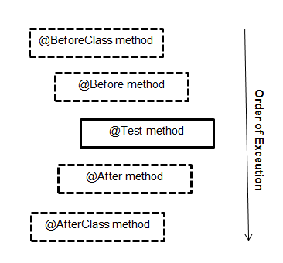](https://i.stack.imgur.com/HKspz.png)

## [XPath for the elements with no ID or Name in Selenium Webdriver](https://www.edureka.co/community/1466/xpath-for-the-elements-with-no-id-name-in-selenium-webdriver)

I don't think Xpath is less preferred then ID and Name.

1. ID might not be unique always, in current websites DOM, IDs are mostly changes by time. You cant stay with one ID and run the script again, if you need to try you can check with Amazon Site as well.
2. Name may be or may not be unique. You are right in some pages you might find elements might have unique names but let's take an example if you have a page with first name and last name sometime dev team just copy and paste those first name lines to last name as well. So now you will find same name attribute in a single page. So you can't rely on name as well.
3. Xpath is unique, because you are the one who is designing the xpath and and you always want an element with unique identity. So now in Name example you can get the first name and last name separately ny xpath.

I believe Xpath is better choice over the Name and ID attribute.

Confident with knowledge

Clarty in what he speak

Active and energetic

Willingness to take responsibilities

Trustworthy & honest

Real exp or fake

Sincere

How he handles tough situations

Strengths and weakness

Positive attitude, Sincere , hard working and honest

Going into too much details sometimes or trying to understand everything in the first place, thinkingf too much while sending mails

<https://www.scalablepath.com/blog/7-qualities-that-differentiate-a-good-programmer-from-a-great-programmer/>

create a maven Project and runner class for cucumber junit

<https://www.tutorialspoint.com/cucumber/cucumber_junit_runner.htm>

<https://www.toolsqa.com/cucumber/cucumber-options/>

@CucumberOptions are used to set some specific properties for the Cucumber test.

Feature file path, step definitions path

***TestRunner Class***



|  |  |
| --- | --- |
| 1  2  3  4  5  6  7  8  9  10  11  12  13  14  15  16 | package cucumberTest;    import org.junit.runner.RunWith;  import cucumber.api.CucumberOptions;  import cucumber.api.junit.Cucumber;    @RunWith(Cucumber.class)  @CucumberOptions(  features = "Feature"  ,glue={"stepDefinition"}  ,dryRun = true  )    public class TestRunner {    } |

**Double Slash “//” –** Double slash is used to create Xpath with relative path i.e. the xpath would be created to start selection from anywhere within the document.

WebDriver driver = new ChromeDriver();

Go into depth of any one concept and ask to write code to test the experience

driver.navigate().back();

***driver.navigate().to();***

Wait concept

Recovery scenario concept

Reporting concept

Running a selenium test concept

Capture all elements in country list box one by one, select one option and come out of list box

For (i=0 ; i<listboxsize ; i++)

{

Driver.findelement(by.xpath()).selectbyvalue

Capture screenshot by webdriver

Explicit wait

wait.until(ExpectedConditions.visibilityOfElementLocated(By.xpath("//div[contains(text(),'COMPOSE')]")));

drv.findElement(By.xpath("//div[contains(text(),'COMPOSE')]")).click();

wait.until(ExpectedConditions.elementToBeClickable(By.xpath(“//div[contains(text(),'COMPOSE')]”)));

wait.until(ExpectedConditions.textToBePresentInElement(By.xpath(“//div[@id= ‘forgotPass'”), “text to be found”));

wait.until(ExpectedConditions.alertIsPresent()) !=null);

wait.until(ExpectedConditions.titleIs(“gmail”));

difference between submit and click

The submit() makes life easier by automatically finding the button and the method that can be appended to any other field like name or email address. In the case of click, we have to use findElement(By, by) method and specify the correct locators.

In some scenarios where the action is done through elements other than a button, submit() works and click() won't.

**Syntax:**

driver.findElement(By.xpath("//input[@name='comments']")).submit();

assertions

Assert.assertEquals(message, “This text”);

Assert.assertNotEquals(message, “This text”);

Assert.assertTrue(result<0);

Assert.assertFalse(result<0);

**Explanation:**

* In the first command, whenever the expected and actual values are same, the assertion passes with no exception. i.e., if the message is “This text”, then the assertion passes.
* In the second command, whenever the expected and actual values are same, the assertion fails with an exception. i.e., if the message is “This text”, then the assertion fails.
* In the third command, if the condition passes, assertion passes. i.e., if result<0, then the assertion passes.
* In the fourth command, if the condition passes, the assertion fails. i.e., if result<0, then the assertion fails.

<https://www.softwaretestinghelp.com/selenium-webdriver-commands-selenium-tutorial-17/>

tables

|  |
| --- |
| WebElement htmltable=driver.findElement(By.xpath("//*[@id='main']/table[1]/tbody")); |

|  |  |
| --- | --- |
| 2 | List<WebElement> rows=htmltable.findElements(By.tagName("tr")); |

|  |  |
| --- | --- |
| 3 |  |

|  |  |
| --- | --- |
| 4 | for(int rnum=0;rnum<rows.size();rnum++) |

|  |  |
| --- | --- |
| 5 | { |

|  |  |
| --- | --- |
| 6 | List<WebElement> columns=rows.get(rnum).findElements(By.tagName("th")); |

|  |  |
| --- | --- |
| 7 | System.out.println("Number of columns:"+columns.size()); |

|  |  |
| --- | --- |
| 8 |  |

|  |  |
| --- | --- |
| 9 | for(int cnum=0;cnum<columns.size();cnum++) |

|  |  |
| --- | --- |
| 10 | { |

|  |  |
| --- | --- |
| 11 | System.out.println(columns.get(cnum).getText()); |

|  |  |
| --- | --- |
| 12 | } |

|  |  |
| --- | --- |
| 13 | } |

**Step 1**: First get the entire HTML table and store this in a variable ‘htmltable’ of type web element.

**Step 2**: Get all the rows with tag name ‘tr’ and store all the elements in a list of web elements. Now all the elements with tag ‘tr’ are stored in ‘rows’ list.

**Step 3**: Loop through each row and get the list of elements with tag ‘th’. ‘rows.get(0)’ will give first row and ‘findElements(By.tagName(“th”))’ will give list of columns for the row.

**Step 4**: Iterate using ‘columns.getsize()’ and get the details of each cell.

**Note**: Above approach will be best suitable if the table dimensions changes dynamically.

This concludes the topic how to handle web tables in selenium. Next, we will learn about handling an element inside a frame.

**Verify Number of frames in a webpage**:

All the frames are having the tag name as “iframe”.

List<WebElement> frameList=driver.findElements(By.tagName(“iframe”));  
System.out.println(frameList.size());

Dynamic elements

**Problem Type 1:**If part of the attribute value changes**.**

**Example**: As in the above example, id value changes but few fields remains constant.  
‘username_123’ changed to ‘username_234’ but ‘username’ always remained constant.

**You can construct xpath as below:**

driver.findElement(By.xpath(“//*[contains(@id,'username')]”)).sendKeys(“username”);  
driver***.***findElement(By.xpath(“//*[starts-with(@id,'user')]”)).sendKeys(“username”);

**Problem Type 2:**If entire value of the attribute changes dynamically.

**For example**: if id of ‘login’ field changes dynamically and there is no constant value to use contains method.

**Step 1**: Enter password   
driver.findElement(By.id(“password”)).sendKeys(“password”));

**Step 2**: Use key functions to navigate to element.  
driver.findElement(By.id(“password”)).sendKeys(Keys.ENTER));  
or  
driver.findElement(By.id(“password”)).sendKeys(Keys.TAB));

<http://www.softwaretestingclass.com/step-by-step-guide-on-database-testing-using-selenium/>

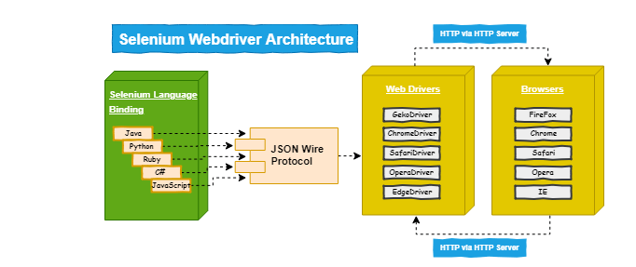

// For the Chrome web browser.

System.setProperty("webdriver.chrome.driver","chrome.exe file path");

WebDriver driver = new ChromeDriver();

<https://www.techbeamers.com/latest-selenium-interview-questions-and-answers/>

advance selenium webdriver questions

<https://www.techbeamers.com/selenium-webdriver-questions/>

<https://www.softwaretestinghelp.com/exception-handling-framework-selenium-tutorial-19/>

Invesco- qa specialist, senior analyst

Ness tech

Mitratech

Pega systems –principal software

Software development engineer- 4 to 8

United health group-5 to 8 years

Enfluence- test professional

Jp morgan

Wells fargo

Cigniti

Ntt data

Accenture

Ea sports- senior qa engineer II

Oracle-senior software engineer in test

Oracle-linkedin-sdet- to be applied

SUMTOTAL

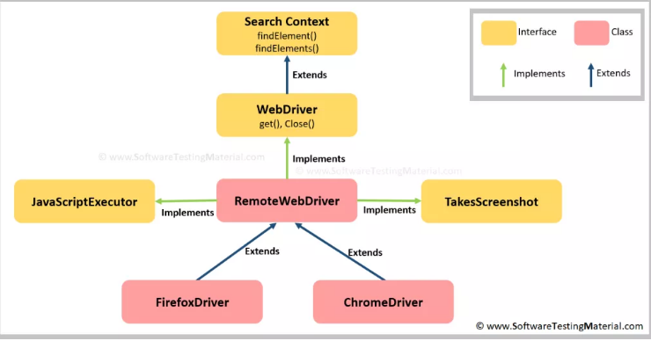

**How would you fill a text field without calling the sendKeys()?**

**Ans.**It's a bit slower than the sendKeys() method but we do have means to type in a text field. See the Java code given below.

JavascriptExecutor JS = (JavascriptExecutor)webdriver;

JS.executeScript("document.getElementById(User').value='admin@testmail.com'");

JS.executeScript("document.getElementById('Pass').value='######'");

Actions act = new Actions(driver);

Act. doubleClick(element).build().perform();

Act. Draganddrop(source_locator, target_locator).build().perform();

<https://www.softwaretestingmaterial.com/javascriptexecutor-selenium-webdriver/>

JavaScriptExecutor JS = (JavascriptExecutor) driver ;(what is the meaning of this?)

JS.executeScript(document.getelementById().click())

To perform scroll in application

Js.executeScript(“window.scrollBy(0,50)”)

Command to press ‘Enter’ key

sendKeys(Keys.ENTER)

navigate.to or get method to enter url in new browser

get method waits until page loads, navigate does not wait

how do you check if object is present in multiple pages

iselement present method

selenium challenges handled

java script executor click

select by index

command to reset exception count to 0

explicit wait

xpath contains

xpath not recognized sometimes due to syntax issues

<http://www.software-testing-tutorials-automatiotion.com/2015/02/how-to-wait-for-page-to-loadready-in.html>

JSON(Java script Object notation) is an alternative to XML. Used for communicating between client-server

What is hashmap in java

Difference between method overriding and overloading

Difference between driver.quit and driver.close

Difference between java class and interface

Rate yourself in java

Language used in protractor

Prokarma

Verisk

Savantis

Techwave consulting- walkin july 20

Bcforward

Multinational bank- live connections

Valuelabs LLP

CIGNITI AUTOMATION TESTER

ADP- automation engineer- 3 to 6 years

FTD-automation lead engineer

Optimum info systems- qa AUTOMATION TEST ENGINEER- 5 to 10 years

VIRTUSA-PENDING

CGI-PENDING-SENIOR SOFTWARE ENGINEER SELENIUM JAVA

Techsopy- senior QA engineer- techsophy

QA Engineer- Amazon

Beghou consulting india pvt ltd

Import package

Public class classname

{

Public static void main(string[], args)

{

Int j = 0

OR

str = driver. findelement.gettext()

Array a = split(str, “ “)

For (int i=0, i < a.size, i++)

{

If(a[i] = test)

{

J++

}

System.out. println(“J”);

}

}

}

<https://www.seleniumeasy.com/selenium-tutorials/read-data-from-properties-file-using-java-selenium>

how do you use object spy- to view all the properties of an object

how do you use object repository- if element not found then modify properties of the object , in some cases use virtual object wizard

how do you identify dynamic elements(using regular expression), using tag in selenium, using assistive properties or ordinal identifier

SetToProperty, GetToProperty, GetRoProperty

Utility objects- example DataTable object, Environment object

**-:Utility and QTP/UFT Objects:-**

1. Crypt Object

2. OptionalStep Object

3. PathFinder Object

4. RandomNumber Object

5. Setting Object

6. WebUtil Object

7. SystemUtil Object

8. RegisterUserFunc Object

9. RepositoriesCollection

DataTable Object

Environment object

QCUtil Object

Few Utility objects in QTP:   
Crypt Object  
DataTable Object  
Description Object  
Environment Object  
QCUtil Object  
RandomNumber Object  
Recovery Object  
Reporter Object  
RepositoriesCollection Object  
Setting Object

TESTing process of two projects agile and waterfall

Test artificats

How you managed your team- stress on your planning and estimation

Do not talk more than required

Keep smiling and answer in slow pace, be attentive,

first create fso object

Set fso = createObject(“scripting.FileSystemObject”)

Use all the methods of the object

Set file = Fso.createtext

Set file = fso.opentext(“location”, ForReading, True)

File.Readline

File.write

Set obj = CreateObject(“Excel.application”)

Obj1 =Obj.Workbooks.open(“”)

Obj2= Obj1.Sheets.Add

Obj2 =Obj1.Sheets(Sheet1)

Set obj1 = nothing

Set obj2 = nothing

obj1.Worksheets(“Sheet1”).usedrange.copy

qtp test for simple login

Browser.page.link(“gmail”).Click

Browser.Page.webedit().setSecure

Browers.page.click

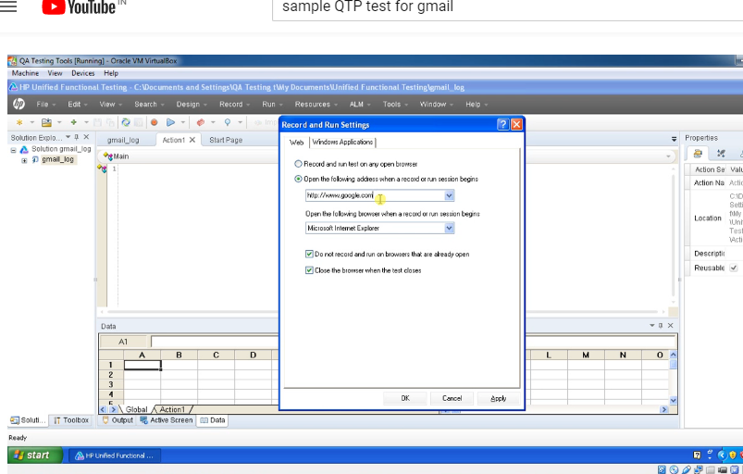

Gave training sessions

Performed on stage

Gave TL Presentations and CSR

It is ok to say I do not remember . not necessary to say all answers. But whatever answered should be clear and crisp and confident

Environment variables- built in, user defined env variables

User defined-For example create URL as an environment variable and use in system util.run

File- test – resources-function library

Eg: OS, resultdir etc

Details about the test in the form of variable

To print a message in UFT

Msgbox environment(“OS”)

Or

Reporter.reportevent 0, login, login is successful

0 for pass, 1 for fail, 2 for message, 3 for warning

Or

Print

Regular expression

Example: order number keeps on changing

Order [0-9]* Completed

UFT waits for 20 sec by default

Do

{

}while()

While

Wend

For

Next

Dim iWeek

iWeek= 3

Select Case iWeek

  Case 1

    msgbox "Today is Sunday"

  Case 2

    msgbox "Today is Monday"

  Case 3

    msgbox "Today is Teusday"

  Case 4

    msgbox "Today is Wednesday"

  Case 5

    msgbox "Today is Thursday"

  Case 6

    msgbox "Today is Friday"

  Case 7

    msgbox "Today is Saturday"

  Case Else

    msgbox "Invalid Number"

End Select

Accept a char and display if it is vower or consonant

str = lcase(Inputbox(“enter a char”))

Select case str

Case a ,e, i ,o ,u

Msgbox

Case else

Msg box

End select

Dim x(3)

Datatable.importsheet(path, fromsheet, tosheet)

N = Datatable.getsheet.getrowcount

For i =1 to n

Datatable.setcurrentrow(i)

To get items count

Getitemscount

Getvisibletext

Dialog.CaptureBitmap “ “

Vb script has only one data type. Can hold any data

Declaration is not mandatory

To make it mandatory...use option explicit

Typecasting- changing from one data type to other

Cstr – character to string

Analog is used for signatures ( occupies more space .. fails when resolution changes..so we use normal recording in general)

Low level is used for non standard objects(text written in mail, for non standard objects)

Web services communicate over a network through HTTP between the two systems.

Soap, REST

API stands for Application Programming Interface which is a protocol used as an interface by software components to communicate with each other. An API serves as an interface between two different applications so that they can communicate with each other.

|  |  |
| --- | --- |
| **WEB SERVICE** | **API** |
| All web services are APIs. | All APIs are not web services. |
| It can only be hosted on IIS. | It can be hosted within an application or IIS. |
| It is not open source but can be used by any client that understands XML. | It is open source and it can be used by any client that understands JSON or XML. |
| It requires a SOAP protocol to receive and send data over the network, so it is not a light-weight architecture. | It is light-weight architectured and good for devices which have limited bandwidth, like mobile devices. |
| A Web service uses only three styles of use: SOAP, REST and XML-RPC for communication. | API may use any style of communication. |
| It only supports the HTTP protocol. | It supports the HTTP protocol: URL, Request/Response Headers, caching, versioning, content formats. |

QC

Select test suite in test lab and run

Connect through citrix, access remote machine, make sure application is open, click on run button in excel macro, excel macro works on top of qc and extract results in custom format

Failed tests can be rerun at once(for issues like vm slow or major defect blocking all tests etc) or run one by one to check in detail placing a breakpoint

Developing new test cases based on req doc

Estimation based on number of steps and functionalities and skills of resources

Tests to be modified are noted down and done after deadlne is over

Efforts to increase automation percentage by test optimization, eliminating unwanted tests

Helping new team members in understanding the application, fixilng failed tests and creating new tests

Learn SAP, Learn how excel macros function, Learn QTP, learn vb script, managing team, finish regression in real short time with few VM machines. Asked to increase vms several times

Recent experience

Fix failed tests that are out of maintenance for an year. Failed due to data issues, tests not updated as per change in functionality, execution is really slow due to ALM.

Challenges: learning the application , interacting in Spanish, getting required data, environment not stable

Best Practices for Code Writing in VB Script

1. At the beginning of every program, write down a brief description of what the program does
2. Provide comments for every variable used during its declaration to briefly describe what this variable is going to do
3. Keep the code modular, as much as possible
4. Have the main program readable and have all the logic segregated in terms of function, so it makes them easy to read and maintain.
5. The segregation of code into functions will also increase reusability
6. An agreed naming convention has to be used to maintain consistency
7. Comments – Provide comments to make the code more understandable
8. Indentation – Make sure that you indent the lines of code to clearly understand the sequence of execution
9. Option Explicit is to be declared so that you don’t run into an issue when you have a spelling mistake in a variable name
10. Watch out for infinite loops

<https://www.softwaretestinghelp.com/test-automation-interview-questions/>

ro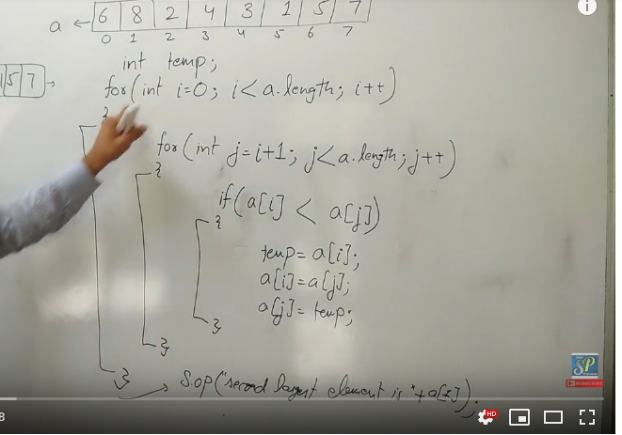

Optionstep keyword

If environment.testname =

Wait 2

Wait function

Synch point

Object properties

Record new screen

Why do you need test strategy

What if you need to test a welcome message

Automation life cycle

Tell your testing process and how you co ordinate team

Java program to find the count of word

Print prime numbers from 1 to 50

Difference between class and interface

Driver. quit and close

Method overriding and overloading

Why protractor

Language used in protractor

Do you know the JD of the project

Challenges in integration testing

r

JPMorgan

Explain your framework folder structure

Driver.close and driver.quit

Driver.close closes the active window(for example window opened when you click on a link)

Driver.quit closes all browser windows(used in @After tag in junit)

Element locators- why css selector not xpath

What is the output of System.out.println(“10+20+ “test”);

How do you click a checkbox inside a listbox

Write code for using chrome driver

// Optional, if not specified, WebDriver will search your path for chromedriver.

System.setProperty( “webdriver.chrome.driver”, “path to chromedriver”);

WebDriver driver = new ChromeDriver(

What is the method for mouse right click

Actions actions = new Actions(driver);

WebElement elementLocator = driver.findElement(By.id("ID"));

actions.contextClick(elementLocator).perform();

doubleclick

Actions actions = new Actions(driver);

WebElement elementLocator = driver.findElement(By.id("ID"));

actions.doubleClick(elementLocator).perform();

How to switch to new tab in selenium?

Need to use window handles

How you rerun the failed tests?

Run TestNG.xml insided failed test folder

Using methods in TestNG class. setTestsuites and run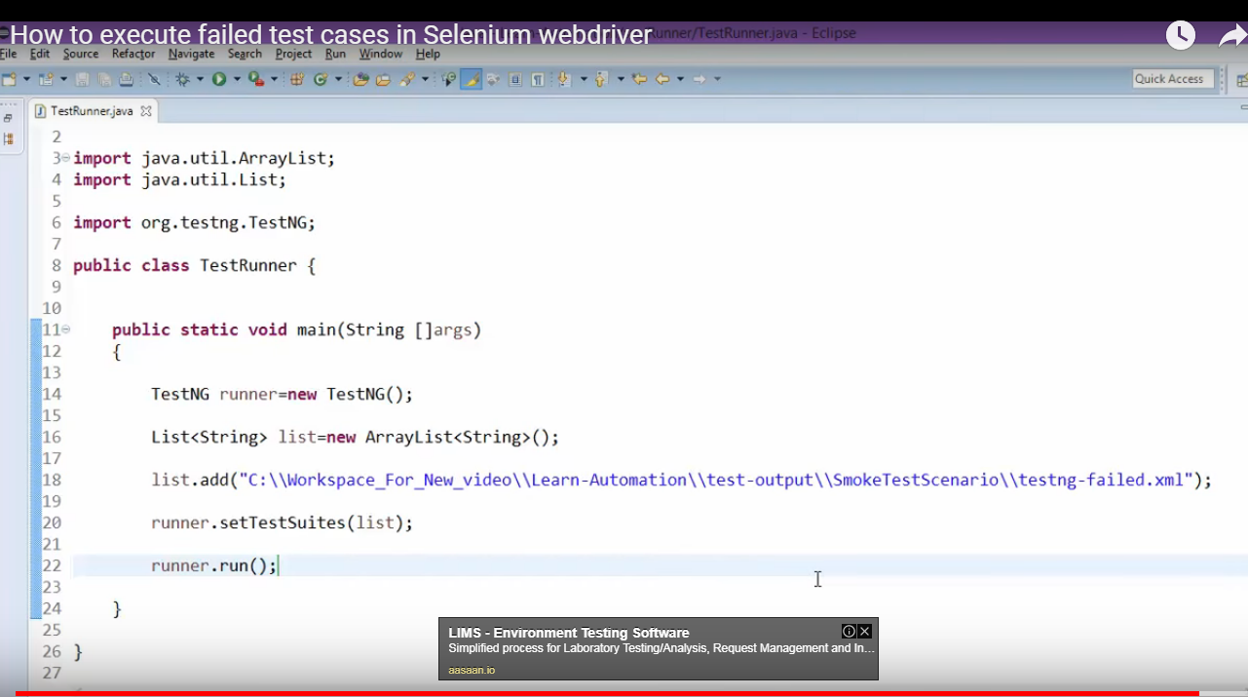

How do you send reports

Difference between Delete and Truncate

Update syntax

Update table set uname = g where cid = 3

What is inheritance

What is the difference between thread.sleep and implicit wait

How do you identify broken links on a web page

Get all links in list by. Tag(a)

Create a connection using

Httpurlconnection Httpurlconnection = (Httpurlconnection)url.openconnection

Using getresponsecode method in get connection

Challenges faced in automation testing- eg: hidden webelement, dynamic elements

Select DISTINCT StudentID, StudentName from Student.

Select * from Student where studentname like 'a%'

1. % - Matches zero or more characters.
2. _(Underscore) – Matching exactly one character.
3. **SELECT** **LEFT**(FullName, CHARINDEX(' ',FullName) - 1) **FROM** EmployeeDetails;

Hidden web element

<https://www.youtube.com/watch?v=2eEr0jtmpwE>

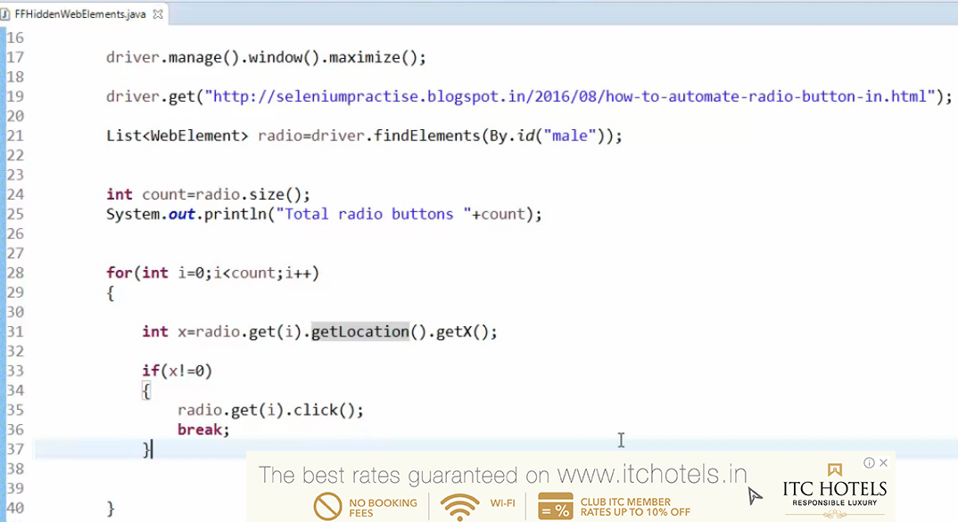

How do you pass data into your tests?

How do you run selected tests using junit?

What are the types of exceptions?

What is stale element exception

.click is used to cclick radio button or checkbox

If the object is not fresh or new, then it is called s tale element

This happens when part of page or entire page gets refreshed and selenium not able to identify

Element identification step to be moved right after page refresh

How to do mouse hover in selenium

act.moveToElement(driver.findelement(By.xpath()).perform();

writing xpath for few elements

writing css for few elements

Framework 1

Feature folder

Java folder

Framework 2

New Maven project -> .idea, Src, newmavenartifact, pom.xml, external libraries

Src -> Main, test

Main-> java, resources

Selenium API –

The API’s are packaged as .jar files in Java world

Selenium components

•  **Language specific client driver** api (selenium source jars)

• **selenium-server-standalone** jar (has an internal http server and hence used as Selenium GRID)

**Maven is a very nice build and configuration tool** that helps us specify the jar as a GAV (group, artifact, version) in a xml file, that helps manage the project dependencies in a succinct manner.

src/test

src/java

what is stale exception

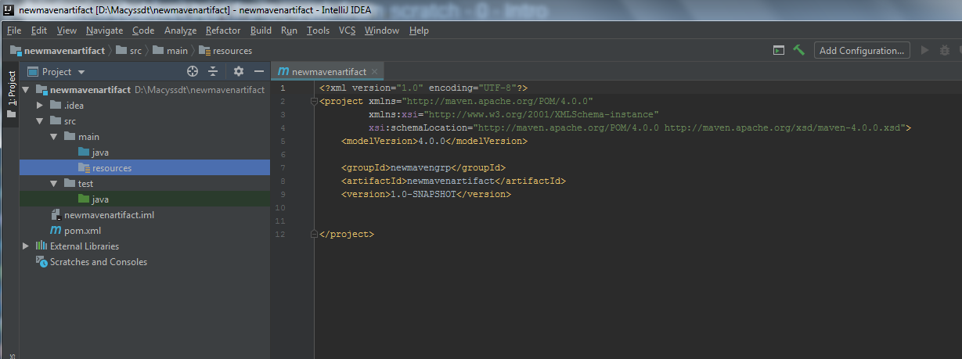

**Controlling ChromeDriver's lifetime**

The ChromeDriver class starts the ChromeDriver server process at creation and terminates it when quit is called. This can waste a significant amount of time for large test suites where a ChromeDriver instance is created per test. There are two options to remedy this:

1. Use the ChromeDriverService. This is available for most languages and allows you to start/stop the ChromeDriver server yourself. See here for a Java example (with JUnit 4):

@RunWith(BlockJUnit4ClassRunner.class)  
public class ChromeTest extends TestCase {  
  
  private static ChromeDriverService service;  
  private WebDriver driver;  
  
  @BeforeClass  
  public static void createAndStartService() {  
    service = new ChromeDriverService.Builder()  
        .usingDriverExecutable(new File("path/to/my/chromedriver"))  
        .usingAnyFreePort()  
        .build();  
    service.start();  
  }  
  
  @AfterClass  
  public static void createAndStopService() {  
    service.stop();  
  }  
  
  @Before  
  public void createDriver() {  
    driver = new RemoteWebDriver(service.getUrl(),  
        DesiredCapabilities.chrome());  
  }  
  
  @After  
  public void quitDriver() {  
    driver.quit();  
  }  
  
  @Test  
  public void testGoogleSearch() {  
    driver.get("http://www.google.com");  
    // rest of the test...  
  }  
}

Python:

import time  
  
from selenium import webdriver  
import selenium.webdriver.chrome.service as service  
  
service = service.Service('/path/to/chromedriver')  
service.start()  
capabilities = {'chrome.binary': '/path/to/custom/chrome'}  
driver = webdriver.Remote(service.service_url, capabilities)  
driver.get('http://www.google.com/xhtml');  
time.sleep(5) # Let the user actually see something!  
driver.quit()

2. Start the ChromeDriver server separately before running your tests, and connect to it using the Remote WebDriver.

Terminal:

$ ./chromedriver  
Started ChromeDriver  
port=9515  
version=14.0.836.0

Java:

WebDriver driver = new RemoteWebDriver("http://127.0.0.1:9515", DesiredCapabilities.chrome());  
driver.get("http://www.google.com");

Collections are used almost in every programming language and when Java arrived, it also came with few Collection classes like List, Set, Maps.

If you find element with same id, name..how you deal with it?

Deal with hidden elements get x! = 0

Get the values in list

getattribute. Value in list box

Oracle

Accenture

Dell

Deloitte

Capgemini

Google

Amazon

CTS

CISCO

INTEL

Symphony services

IBM

Microsoft

TCS

JUNIPER

Goldman sachs

Infosys

How many automation qa are present

There are two types of access modifiers:

* Top-level access modifiers: **public** and default (default is when no access modifier is used). These access modifiers apply to types only (classes, interfaces, enums and annotations).
* Member-level access modifiers: **public**, **protected**, default and **private**. These access modifiers apply to fields, constructors and methods.

always apply the most restrictive access modifier unless you have reasons to use the less restrictive ones. For example, all fields in a class should be private by default, and all the behaviors are public.

**NOTE**: local variables (within a method body) do not have access modifiers because they are accessible only within the method itself.

To summary, remember the order of access modifiers from the least restrictive to the most restrictive:

**public > protected > default > private**

Polymorphism

In Java, polymorphism is based on inheritance and overriding.

<https://www.codejava.net/java-core/the-java-language/what-is-polymorphism-in-java-the-what-how-and-why>

**skills to be developed**

designing frameworks selenium java , writing java programs, SOAP UI, JMETER, Phython, Java script, micro services, c-sharp, TestNG, GIT, Jenkins, security testing, RTF

smart prep

write code, explain framework, how you execute tests, java hashmaps , interface,

smart present

talk dead slow, start with informal talk and keep smile on face, keep your answers short and brief, do not tell unnecessary things like you are not a programmer etc, end the interview tell your strong areas- goal is to be automation architect, willing to learn new automation tools, passion to automate all tests , fixing failed tests, looks for continuous improvement, giving my 100%, stay committed for long time, more happy mond to frid, . Your interesting areas, willingness to learn technologies and the challenges you faced successfully,

ASG- Selenium, Ruby, SoapUI Pro, SQL, VM, Agile scrum

Execute one after other in local

Execute the test suite

Give parameters in sauce labs and execute

Partitions

Intellij- run configurations- add, main runner class, parameters like feature file, browser etc

Junit runner class- @Runwith, @cucumberoptions

Obtain results from Jenkins and display

Gitpull

Create new branch

Challenges in Selenium automation testing

* 1. [We cannot test windows application](https://www.softwaretestingmaterial.com/challenges-and-limitations-of-selenium-webdriver/" \l "We-cannot-test-windows-application)
* No work around
* 2. [We cannot test mobile apps](https://www.softwaretestingmaterial.com/challenges-and-limitations-of-selenium-webdriver/#We-cannot-test-mobile-apps)
* Appium to be used
* 3. [Limited reporting](https://www.softwaretestingmaterial.com/challenges-and-limitations-of-selenium-webdriver/" \l "Limited-reporting)
* TestNG to be used or ‘cross browser testing’ tool
* 4. [Handling dynamic Elements](https://www.softwaretestingmaterial.com/challenges-and-limitations-of-selenium-webdriver/" \l "Handling-dynamic-Elements)
* Dynamic xpath functions and css selector to be used
* 5. [Handling page load](https://www.softwaretestingmaterial.com/challenges-and-limitations-of-selenium-webdriver/" \l "Handling-page-load)
* Use explicit wait in case of dynamic list box
* 6. [Handling pop up windows](https://www.softwaretestingmaterial.com/challenges-and-limitations-of-selenium-webdriver/" \l "Handling-pop-up-windows)
* Auto IT to be used for Windows based pop up
* However, since Selenium WebDriver can operate multiple windows, web-based alerts can usually be handled with the switchTo method to control the pop-up while keeping the browser in the background.
* 7. [Handling captcha](https://www.softwaretestingmaterial.com/challenges-and-limitations-of-selenium-webdriver/" \l "Handling-captcha)
* Limitation in selenium
* Multi-tab Testing

Selenium WebDriver has the ability to test in multiple tabs, but it might present as an obstacle if you don’t know the correct commands. For example, if you want to open a new tab to perform a specific action without leaving the original tab, you’ll still want to be able to control both tabs and go back to the parent tab if users are likely to perform these kinds of actions. The best method for this is to store the previous window handle in a variable and then continue in the new window and store that in a second variable. Then, you can use the switchTo method to go between both windows as needed.

Manual testing and Visual testing

In fact, a lot of automation relies on basic manual testing efforts. Rather, learning to [prioritize which tests to automate](https://crossbrowsertesting.com/blog/test-automation/prioritizing-test-automation/) will be beneficial to any tester.

Selenium WebDriver lacks capabilities for visual testing, which is important for testing beyond functionality to assess overall user experience. The most efficient way to do visual testing is by outsourcing to a third-party screenshot tool that integrates with Selenium.

Common issues that are solved in selenium

Handling dynamic elements

should always write dynamic or custom XPath or class which can make our script more stable.

Selectbyindex

Explicit wait

Java script click when click does not work

Reset failure count to 0

Place the element locators in responsive to run it for mobile

Unwanted spaces in xpath

Alert alert = driver.switchTo().alert();

alert.accept();

scroll mouse

Actions.moveToElement(driver.findElement(By.id("id of the dropdown"))).perform();

Git pull

Git checkout -b “Feature/B-BBaboutsubfix” master

Git add file1 file2 file3

Git commit -m “B-128856VB-BBaboutsubfixʼʼ

Git push origin/master Feature/B-BBaboutsubfix

A primary key is a combination of fields which uniquely specify a row. This is a special kind of unique key, and it has implicit NOT NULL constraint. It means, Primary key values cannot be NULL.

**What is the difference between DELETE and TRUNCATE commands?**

DELETE command is used to remove rows from the table, and WHERE clause can be used for conditional set of parameters. Commit and Rollback can be performed after delete statement.

TRUNCATE removes all rows from the table. Truncate operation cannot be rolled back.

Base class

Test base class is inside tests folder

Initialize webdriver, implicit wait ,quit browser, extent report, create object for file input stream, logger, properties, common methods.

Browser type, url, screenshot path etc are placed in config.properties (properties file)

Utilities- all repetitive functions like(Utilities folder is same a s common functions folder)-Waits, Sending emails, DB CONNECTION, TAKE SCREENSHOT, JAVA SCRIPT UTIL

Test NG for assertions, grouping, parallel execution

Maven for build, execution, dependencies

COMMON UTILS ARE USED BY PAGE LAYER AND TEST CASE LAYER

Log4j api is used to log a message in test result. ‘Extent report’ is used to generate html reports

Pom.xml hav Test ng jar Poi jar

POM.XML IS EXECUTED BY Jenkins to run every time

Pom.xml will interact with testing.xml to run tests

Extent reports is used to generate html reports and display screenshots

POM architecture in Selenium - <https://www.youtube.com/watch?v=9uxlY_IPIY8-> naveen automation labs

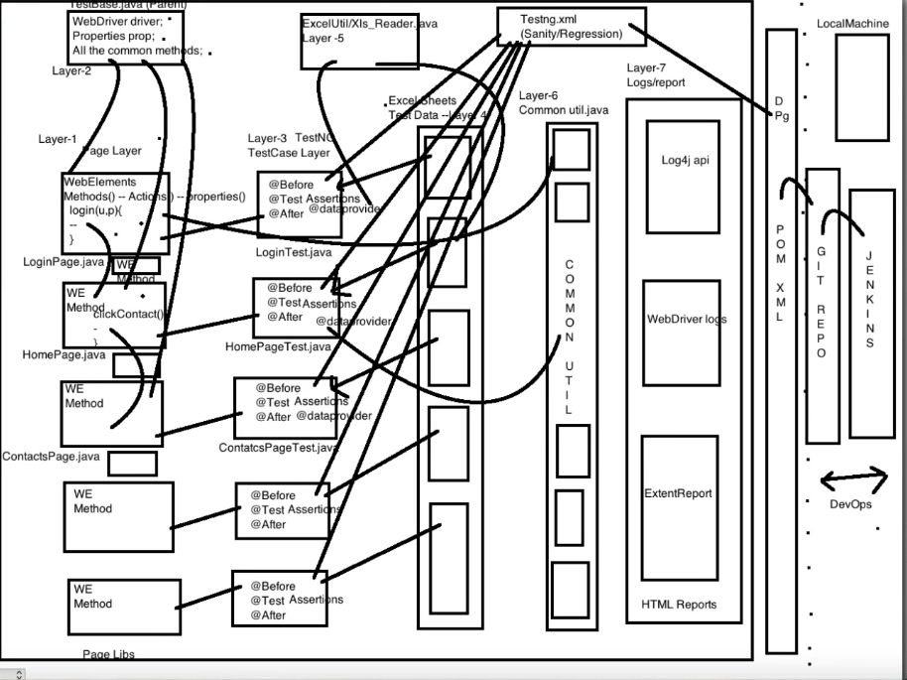

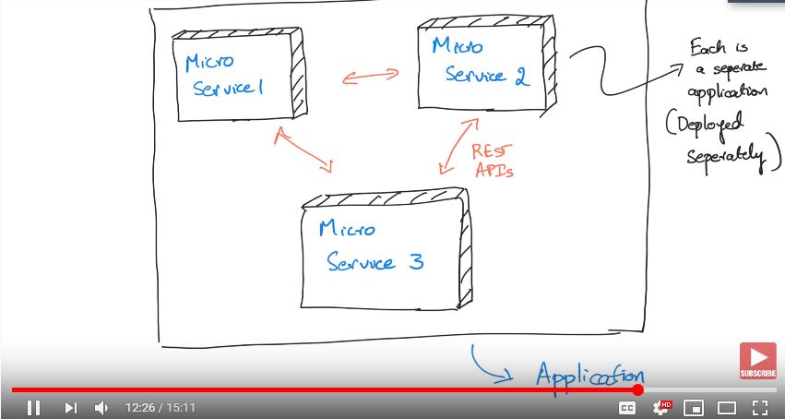

API

Micro services are connected via API’s

example - some online payment system can provide both a regular web site (to be used by humans) and some API (to be used from a computer program).

A **web service** is a SW service that is provided through Web/HTTP(s

The most popular and standard way to organize a web service is called REST (Representational State Transfer), but there are other ways (such as SOAP/WSDL).

Change environment variables and run it for mobile to test responsive website

Integration testing

Bottom up approach

Top down approach

Driver

Stub

stay confident your knowledge, talk dead slow, tell your strengths at end, and your goal, write test cases for real time scenarios,

write test plan and strategy, test metrics, practice writing 3 selenium tests and java programs, some 10 practical sql questions,

api, microservices, sql, json, xml, automation life cycle, review your existing doc..

Rule class and evaluate method is used for retry logic using junit

Test Ng- run directly failed.xml, to do it automatically we use TestNG class and set testsuite and run methods

Rerun failed cucumber scenarios using junit in java- change the features folder path in runner class

<https://www.youtube.com/watch?v=odDOirv4Y7M>

Test metrics

**#1) %ge Test cases Executed**:

**#2) %ge Test cases not executed**:

**#3) %ge Test cases Passed**:

**#4) %ge Test cases Failed**:

**#5) %ge Test cases Blocked**:

**Defect Density =**No. of Defects identified / specific requirement or functionality

Defect Density is calculated as a number of defects identified per requirement.

**#7) Defect Removal Efficiency (DRE) = (**No. of Defects found during QA testing / (No. of Defects found during QA testing +No. of Defects found by End-user)) * 100

**$8) Defect Leakage:**Defect Leakage is the Metric which is used to identify the efficiency of the QA testing i.e., how many defects are missed/slipped during the QA testing. Defect Leakage**= (**No. of Defects found in UAT / No. of Defects found in QA testing.) * 100

**#9) Defects by Priority**:

%ge Critical Defects = No. of Critical Defects identified / Total no. of Defects identified * 100

Writing test cases

**Step 1: Partition your input into categories**

**Step 2: Construct your decision table.**

**Why xpath is slower, why not css selector**

**Explain explicit wait and fluent wait**

**Selenium web driver architecture**

**Selenium project framework**

**Oops concepts with explanation**

**Method overriding and overloading, practical question**

**Why selenium not any other open source**

**What is stale element exception**

**When do you get webdriver exception**

**How do you select multiple options in a list box**

**Changes required in preparation**

1. **deep understanding of the concept is required- watch video training or detail tutorial**
2. **Remember the example code or diagram of each concept to explain**
3. **predict the interview questions you might get on this concept, and go through practical or coding level interview questions**

**fee 8k**

**prayer 13k**

**by default wait poll time is 500 milli seconds**

when we have to use Custom condition then only go with Fluent Wait else WebDriverWait will be more than sufficient.

REPLY

Using implicit wait in base class is not a good idea. Better to keep the function in utilities and call wherever required

It is better to use either implicit or explicit ...do not mix both

Explicit or fluent wait is highly preferred

2. Implicit wait(30) > Explicit Wait(10)

When explicit wait stars looking for element, it needs to wait for 30 seconds because of implicit wait time.

What happend in below scenarios,

Implicit wait(10) < Explicit Wait(30)

it will throw exception after 10 seconds and not wait for Explicit Wait

**Naveen automation labs**

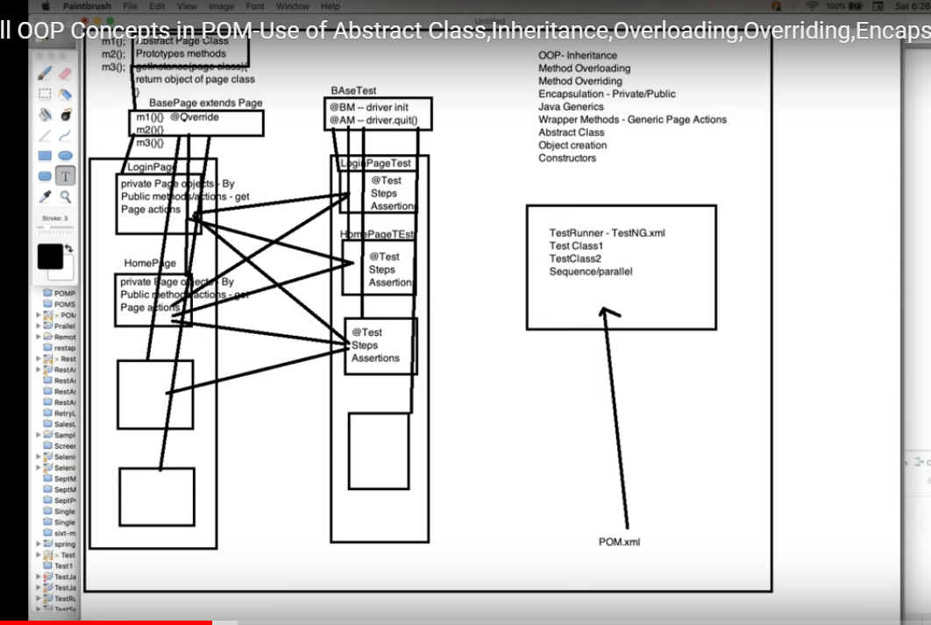

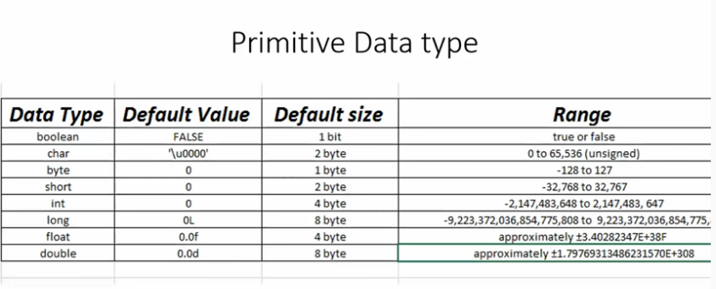

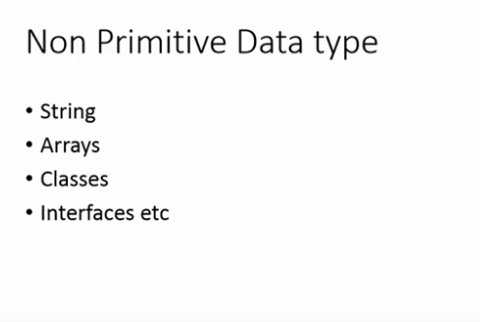

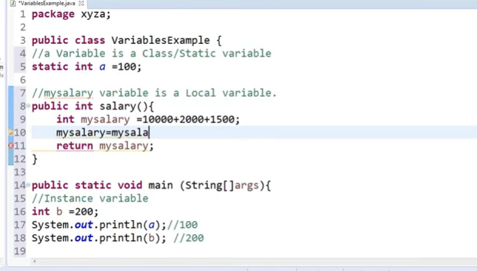

Association of method call to the method body is known as binding. There are two types of binding: **Static Binding** that happens at compile time (eg: Method overloading)and **Dynamic Binding** that happens at runtime (Method overriding)

4.  We can delete cookies in 3 ways.

driver.manage().deleteCookieNamed("CookieName");

driver.manage().deleteCookie(CookieId);

driver.manage().deleteAllCookies();

**What does this regular expression match?**

regexp:[1-9][0-9],[0-9]{3},[0-9]{4}

**Assume, you are using the number 1.**

* 1.  11,11,11
* 2.  11,11,111
* 3.  11,111,1111
* 4.  11,3,4

**Why would you like to choose WebDriver over Selenium RC?**

* 1.  WebDriver has native web browser support and runs faster than RC.
* 2.  All of these.
* 3.  WebDriver does not need the Selenium RC server to be running.
* 4.  WebDriver supports headless HTMLUnitDriver that enables faster test execution.

**Xml parser is a valid component of UI automation**

**Changing user agent**

FirefoxProfile profile = new FirefoxProfile();

profile.addAdditionalPreference("general.useragent.override", "some logical name");

WebDriver driver = new FirefoxDriver(profile);

**Globbing text pattern is used in selenium**

**Using relative xpath we can handle dynamic elements**

Int size = driver.findElements(By.tagName("iframe")).size();

Basically, we can switch over the elements in frames using 3 ways.

* **By Index**
* **By Name or Id**
* **By Web Element**

driver.switchTo().frame(0);

driver.switchTo().frame("iframe1");

driver.switchTo().frame("id of the element");

clicking images. Accessing image link is done using By.cssSelector()

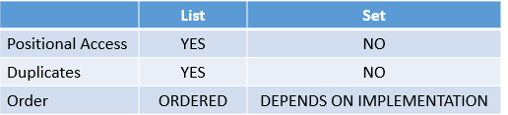

Tcs ion

Tc@1234

WebDriver is an interface provided by Selenium WebDriver.

interfaces in Java are the collection of constants and abstract methods(methods without any implementation). The WebDriver interface serves as a contract that each browser-specific implementation like ChromeDriver, FireFoxDriver must follow. The WebDriver interface declares methods like get(), navigate(), close(), sendKeys() etc. and the developers of the browser specific drivers implement these methods to get the stuff automated.

EventFiringWebDriver is a class and is **used to wrap your webdriver around to throw events** and WebDriverEventListner is an interface that you have to implement to catch the webdriver events.

# Remote WebDriver

You can use WebDriver remotely the same way you would use it locally. The primary difference is that a remote WebDriver needs to be configured so that it can run your tests on a separate machine.

A remote WebDriver is composed of two pieces: a client and a server. The client is your WebDriver test and the server is simply a Java servlet, which can be hosted in any modern JEE app server.

To run a remote WebDriver client, we first need to connect to the RemoteWebDriver. We do this by pointing the URL to the address of the server running our tests. In order to customize our configuration, we set desired capabilities. Below is an example of instantiating a remote WebDriver object pointing to our remote web server, [*www.example.com*](https://www.example.com/), running our tests on Firefox.

* [Java](https://www.selenium.dev/documentation/webdriver/drivers/remote_webdriver/#tabs-0-0)
* [Python](https://www.selenium.dev/documentation/webdriver/drivers/remote_webdriver/#tabs-0-1)
* [CSharp](https://www.selenium.dev/documentation/webdriver/drivers/remote_webdriver/#tabs-0-2)
* [Ruby](https://www.selenium.dev/documentation/webdriver/drivers/remote_webdriver/#tabs-0-3)
* [JavaScript](https://www.selenium.dev/documentation/webdriver/drivers/remote_webdriver/#tabs-0-4)
* [Kotlin](https://www.selenium.dev/documentation/webdriver/drivers/remote_webdriver/#tabs-0-5)

FirefoxOptions firefoxOptions = new FirefoxOptions();

WebDriver driver = new RemoteWebDriver(new URL("http://www.example.com"), firefoxOptions);

driver.get("http://www.google.com");

driver.quit();

Copy

To further customize our test configuration, we can add other desired capabilities.

## Browser options

For example, suppose you wanted to run Chrome on Windows XP, using Chrome version 67:

* [Java](https://www.selenium.dev/documentation/webdriver/drivers/remote_webdriver/#tabs-1-0)
* [Python](https://www.selenium.dev/documentation/webdriver/drivers/remote_webdriver/#tabs-1-1)
* [CSharp](https://www.selenium.dev/documentation/webdriver/drivers/remote_webdriver/#tabs-1-2)
* [Ruby](https://www.selenium.dev/documentation/webdriver/drivers/remote_webdriver/#tabs-1-3)
* [JavaScript](https://www.selenium.dev/documentation/webdriver/drivers/remote_webdriver/#tabs-1-4)
* [Kotlin](https://www.selenium.dev/documentation/webdriver/drivers/remote_webdriver/#tabs-1-5)

ChromeOptions chromeOptions = new ChromeOptions();

chromeOptions.setCapability("browserVersion", "67");

chromeOptions.setCapability("platformName", "Windows XP");

WebDriver driver = new RemoteWebDriver(new URL("http://www.example.com"), chromeOptions);

driver.get("http://www.google.com");

driver.quit();

<https://artoftesting.com/meaning-of-webdriver-driver-new-firefoxdriver#What_is_WebDriver>

<https://www.selenium.dev/documentation/webdriver/drivers/remote_webdriver/>

format to write customized xpath

 //tag-name[@attribute='attribute value']

The differences between get() and navigate() methods are listed below.

| **sl.no.** | **get()** | **navigate()** |
| --- | --- | --- |
| 1 | It is responsible for loading the page and waits until the page has finished loading. | It is only responsible for redirecting the page and then returning immediately. |
| 2 | It cannot track the history of the browser. | It tracks the browser history and can perform back and forth in the browser. |

Stale element referenceexception

What would be the exception thrown by the WebDriver if the web page is refreshed after the element was located?

The color of a WebElement can be found by using the following WebElement method- getcssvalue(“”)

If the page doesn't load in 1 second, then throw the TimeoutException. Below is the command for it

d.manage().timeouts().pageLoadTimeout(1, TimeUnit.SECONDS);

Primitive Data types: int, double, float, char

Int, long, short, byte are all integer datatypes

Double is a float datatype (ex: 12.2345)

Non Primitive Data types: Strings, Arrays, Classes, Interface.

The main difference between **primitive** and **non-primitive** data types are:

* Primitive types are predefined (already defined) in Java. Non-primitive types are created by the programmer and is not defined by Java (except for String).
* Non-primitive types can be used to call methods to perform certain operations, while primitive types cannot.
* A primitive type has always a value, while non-primitive types can be null.
* A primitive type starts with a lowercase letter, while non-primitive types starts with an uppercase letter.
* The size of a primitive type depends on the data type, while non-primitive types have all the same size.

An identifier in java is a name given to a variable, class, method and labels

**Object class in java is ____**?

Super class of all the classes i.e. every class in java extends object class by default

An instance variable remain alive as long as the object it belongs to is alive

A final variable cannot be changed, therefore it will give a compilation error- the final field cannot be assigned.

Below is the example

*public class finalTest {  
final static int r=9;  
public static void main(String[] args) {  
r++;  
System.out.println(r);  
}  
}*

*public class finalTest {  
finalTest func1() {  
System.out.println("This is func1");  
return new finalTest();  
}  
String func2() {  
return "returning string2";  
}  
  
public static void main(String[] args) {  
finalTest obj2;  
obj2=new finalTest();  
System.out.println(obj2.func1().func2());  
}  
}*

*output is*

*This is func1  
returning string2*

because dot operator has left associativity therefore func1 will be called first which returns an object of finalTest class, which in turn make a call to func2

A final method cannot be overridden in a subclass

*class test123 {  
test123(){  
System.out.println("Constructor Superclass");  
}  
}  
  
public class finalTest extends test123{  
finalTest(){  
System.out.println("Constructor sub class");  
}  
public static void main(String[] args) {  
finalTest obj2=new finalTest();  
}  
}*

*output*

 *Constructor Superclass  
Constructor sub class*

An instance or static variable if not explicitly initialized, then they acquire default value or implicitly get initialized with a default value.

*public class finalTest {  
int var1;  
public void func2() {  
System.out.println(var1);  
}  
public static void main(String[] args) {  
finalTest obj2=new finalTest();  
obj2.func2();  
}  
}*

output is “0”

Following axis will select every tag after the current node.

Find all the anchor tags in the entire DOM which are falling after the list item whose id is 'firstItem'

**contextClick() method of the Actions class performs __________ operation**?

Rightclick

Continue statement breaks one iteration

Java for beginners edureka tutorial

https://www.youtube.com/watch?v=aqHhpahguVY

* + Support platform is missing where they find solutions immediately
  + Direct Guidance in understanding
  + Real complete project or website examples for all concepts
* <https://artoftesting.com/selenium-java-automation-framework>

default time for waitfor is 30 seconds

variables are stored in storedVars

press alt f9 to execute a specific command

Running tests in parallel in TestNG

In order to run the tests in parallel just add these two key-value pairs in suite-

* Parallel =”{methods/tests/classes}”
* thread-count =”{number of thread you want to run simultaneously}”.

What is used to check page title

Assert title

Command used to compare contents of table with expected values

Verifytable

1. assert - If the expected value is mandatory to continue with the next set of steps we will use Assert. As Assert aborts the test, if the expected value doesn't match. It is good to use for any mandatory checks.  
   2) verify - If the expected value is optional to continue with the next set of steps we will use Verify. As Verify continues executing with the next set of steps, if the expected value doesn't match. It is good to use for any optional checks.  
   3) waitFor - If your test needs to wait, if the expected value is not matching we use waitFor. We normally use waitFor for AJAX kind of controls loading within a page.

In TestNG, the **Verify** functionality is provided by means of the **Soft Assertions** or using **SoftAssert** class.

Need to understand assertions

Distinct values in java

import java.io.*;

public class Demo{

   static void distinct_vals(int my_arr[], int len){

      for (int i = 0; i < len; i++){

         int j;

         for (j = 0; j < i; j++)

         if (my_arr[i] == my_arr[j])

            break;

         if (i == j)

         System.out.print( my_arr[i] + " ");

      }

   }

   public static void main (String[] args){

      int my_arr[] = {55, 67, 99, 11, 54, 55, 88, 99, 1, 13, 45};

      int arr_len = my_arr.length;

      System.out.println("The distinct elements in the array are ");

      distinct_vals(my_arr, arr_len);

   }

}

Different ways to find unique elements in java

<https://www.javatpoint.com/find-unique-elements-in-array-java>

<https://www.youtube.com/watch?v=x7yTo47dqTo>

Different ways to reverse a string

<https://www.geeksforgeeks.org/reverse-a-string-in-java/>

<https://www.youtube.com/watch?v=1_hhywLAO5o&t=1131s>

gap – navigation does not work on android phone etc.,

cigars -

hrw – move folder is deleting files

“break” statement stops execution

“continue” statement stops current iteration and moves to next iteration.

Array is a **data structure** which holds the sequential elements of the same type.

Initialization of array: int a[] = new int[12]

‘int table[][] = new int[4][5];

To read or print an array we need to writed nested loop – one loop for row “i” and inside that another loop for column j

for(i=0;i<4;i++)

{

for(j=0;j<5;j++)

{

System.out.Println(invoice[i][j]);

}

}

Java access modifiers

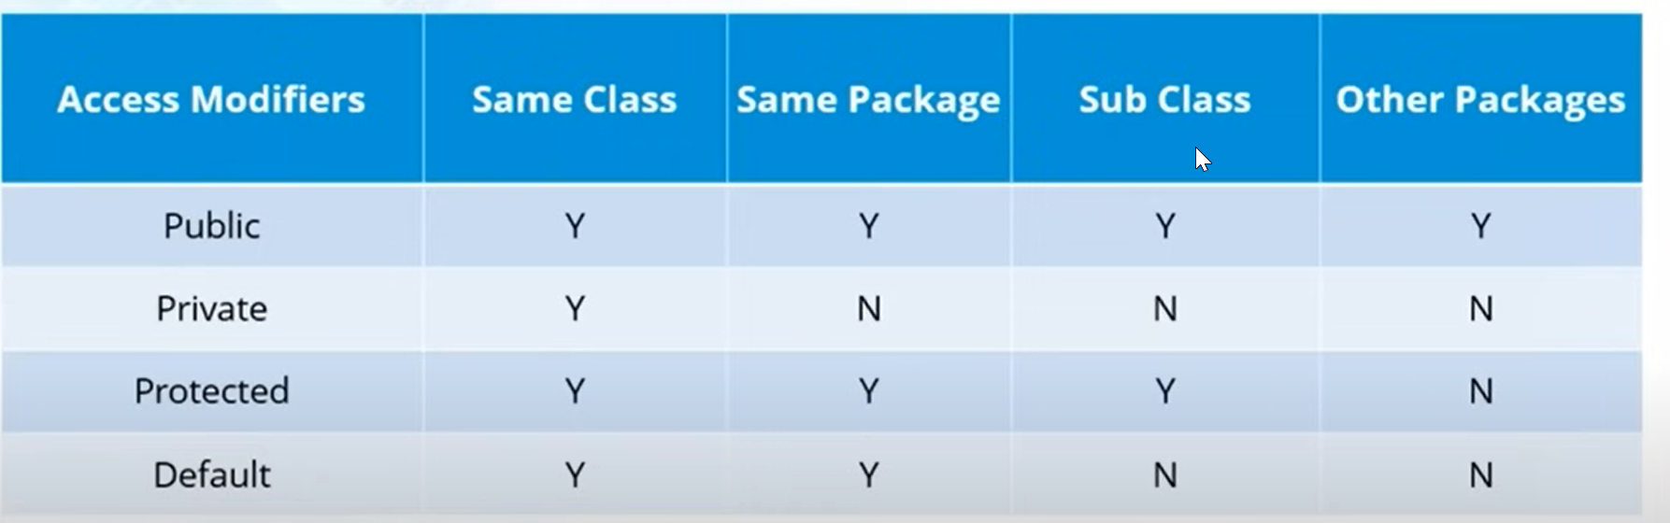

Keyword driven framework

For each test case step if you are calling a keyword or function, then it is called keyword driven framework

Example

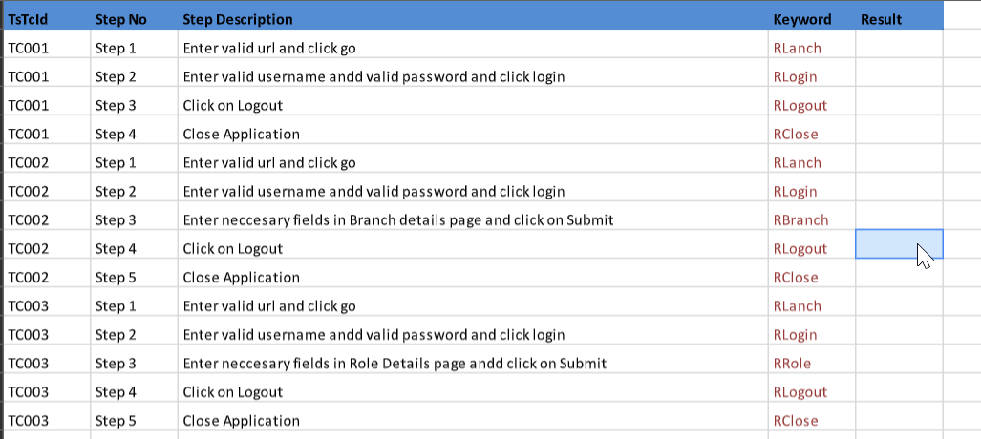

What is Scenario Outline in feature file?

Scenario Outline is the same scenario can be executed for multiple sets of data using the scenario outline. The data is provided by a tabular structure separated by pipes i.e (I I)

What are the different types of frameworks?

Below are the different types of frameworks:

Module Based Testing Framework: The framework divides the entire “Application Under Test” into the number of logical and isolated modules. For each module, we create a separate and independent test script. Thus, when these test scripts have taken together builds a larger test script representing more than one module.

Library Architecture Testing Framework: The basic fundamental behind the framework is to determine the common steps and group them into functions under a library and call those functions in the test scripts whenever required.

Data Driven Testing Framework: Data Driven Testing Framework helps the user segregate the test script logic and the test data from each other. It lets the user store the test data into an external database. The data is conventionally stored in “Key-Value” pairs. Thus, the key can be used to access and populate the data within the test scripts.

Keyword Driven Testing Framework: The Keyword Driven testing framework is an extension to Data-driven Testing Framework in a sense that it not only segregates the test data from the scripts, it also keeps the certain set of code belonging to the test script into an external data file.

Hybrid Testing Framework: Hybrid Testing Framework is a combination of more than one above mentioned frameworks. The best thing about such a setup is that it leverages the benefits of all kinds of associated frameworks.

Behavior Driven Development Framework: Behavior Driven Development framework allows automation of functional validations in an easily readable and understandable format to Business Analysts, Developers, Testers, etc.

Difference between tagname and css locators. Why css is better?

findElement(By.tagName("a_tag")) will find elements by html tags such as <iframe> , <div>. But you can only provide it with html tags, not css classes, etc ...

With findElement(By.cssSelector("a_tag")) you can find elements with html tags but you can also give a css class for example findElement(By.cssSelector("div.myClass"))

Click on element with Co-ordinates

ClickAt

Fetch message of alert pop up

StoreAlert or alert.gettext

Commands To verify UI

verifyElementPositionLeft

verifyElementPositionTop

getCssValue

Breakpoints: When you implement a breakpoint in your code, the execution will stop right there. This helps you to verify that your code is working as expected.

StartpointsStartpoint indicates the point from where the execution should begin. Startpoint can be used when you want to run the testscript from the middle of the code or a breakpoint.

To handle network latency you can use driver.manage.pageloadingtime for network latency

You can customize TestNG report in two ways,

Using ITestListener Interface

Using IReporter Interface

To generate pdf reports, you need Java API IText.

**Mention what is Listeners in Selenium WebDriver?**

In Selenium WebDriver, Listeners "listen" to the event defined in the selenium script and behave accordingly. It allows customizing TestNG reports or logs. There are two main listeners i.e. WebDriver Listeners and TestNG Listeners.

Desired Capabilities

can be used to configure the driver instance of Selenium WebDriver.

When you want to run the test cases on a different browser with different operating systems and versions.

Session Handling

Best Demo topics

* XPath - done
* TestNG -
* Page object model with page factory - done
* Basics of Java and OOPS Concepts
* Datadriven testing
* Database verification
* Wait concept

Things to read

Cucumber

Selenium IDE

Github

Different ways of parameterization

Database testing

TestNG XML practice

Java programs like distinct values, reverse a string

Listeners

Jenkins

Logg4j

Things to be learned

Javascript

Appium

Jmeter

Restassured

Python – learnpython.org and practice basic concepts

Freecodecamp- beginner projects